**PERFORMANCE ASSESSMENT OF A MYOELECTRIC DEEP SENSING HAND PROSTHESIS**

**1. INTRODUCTION**

The World Health Organization (WHO) estimated in 2017, that around the world 0.5% of the total number of people need prostheses, orthoses and rehabilitation treatment, which is equivalent to approximately 35 to 40 million people. On the other hand, in that same study they pointed out that between 85% and 95% of people who require the use of some orthopedic support device such as prosthesis or orthosis, do not have access to these due to their high costs [1]. Meanwhile, according to a market study conducted by the consulting and market research company Grand View Research, there are more than 100 million people in the world with limb loss and about one million amputations are performed annually [2].

The importance of the hand lies in the fact that this limb is extremely versatile, one can perform complex movements and grips that allow day-to-day activities [3]. For this reason, when a person loses his or her upper limb, the physician recommends acquiring a prosthesis that allows him or her to recover the necessary functionality to perform his or her tasks more easily [4].

In recent decades, prostheses that use myoelectric signals to improve their function have been developed and marketed [4]. However, the biggest problem with these prostheses is their high cost in the current market, since they have an approximate price that starts at $ 6,600 USD for prostheses such as the Hero Arm from Open Bionics and can reach up to $ 60,000 USD such as the Michelangelo Hand from Ottobock [5].

Deep sensing function is an important feature to add in neuroprosthetic prosthetic hands because it provides the tactile feedback that is lost during hand amputation. This sensing system is achieved with a touch sensor to measure the force or pressure, and a stimulator to provide the feedback on the skin of the residual limb. The stimulator could be a vibration motor or an electrical stimulation. It is important to mention that the feedback in both cases is non-invasive, and in some research invasive approaches have been studied. However, most commercial prosthetic hands do not have deep sensing function due to high cost, so the amputees cannot have sensory feedback while doing the grasps.

In that sense, the need persists to provide a more affordable alternative for upper limb amputees, without compromising the efficacy and utility of the prosthesis. Therefore, **the ultimate goal of this project** is to develop a low-cost deep sensing myoelectric transradial prosthesis with different grasp types. To achieve this goal, it is necessary to have a closed loop model with bio-feedback (provided by the EMG signals), environmental feedback (provided by the forces on the fingertips), and prosthetic actuation system (action is achieved by the motors and vibrators).

**2. Objectives**

The objective of this study is to provide numerical and analytical models that can:

1. Map EMG signals to different grasp configurations via classification.
2. Map EMG signals to finger joint angles via regression.
3. Map forces on the fingertips to the vibrations on forearm skin (sensory substitution).
4. Closed-loop model between bio-feedback, environmental feedback, and prosthetic hand action.

**2.1 Specific Aims**

1. We will determine if the recorded EMG signals from low-cost sensors provide a good classification similar to gold-standard sensors.
2. We will identify which time-domain features extracted from the EMG data provide highest sensors output and specificity in classification.
3. We will identify which classification algorithm, machine learning and deep learning models, have the best performance predicting the grasp types using the extracted EMG data.
4. We will determine whether changes in the number of grasp types are associated with the algorithm performance.
5. We will identify which regression algorithm, machine learning and deep learning models, have the best representation to map the EMG signal with the finger joint angels during different grasps.
6. We will develop a function that maps fingertip forces to vibration stimulation on the skin; this behaviour should effectively substitute the lost sensory feedback from the amputee hand.
7. We will develop a closed-loop function which can effectively fuse the EMG signal and forces on fingertips and provides both motor movement and vibration stimulation on the skin.

**3. Hypothesis**

1. The quality of EMG data obtained using four channel MYOstack sensor will give good performance metrics in the classification algorithm, with similar values to the ones obtained from Trigno sensor.
2. The motion trackers in the finger joints and EMG sensors in the forearm provide sufficient information to generate a regression model which accurately maps the joint angles during grasps.
3. The vibrator actuators on the arm skin provides sufficient information to transfer the force applied at fingertips.

**4. Methodology**

**4.1 Participants**

After obtaining approval from the University of Alberta Research Ethics Board (REB), 40 able-bodied volunteers will be invited to consent and participate in this study. The sample size would be enough to have a normal distribution of the sample means, following the central limit theorem. Participants will be recruited via ads placed in the university campus, on the university digest emails and social media as well as word of mouth.

**4.1.1 Inclusion and exclusion criteria**

We will include males and females, aged between 20 and 65, with no neuromuscular or musculoskeletal movement disorders and able to read and understand English instructions. Also, participants with the following will be excluded:

1. Pain or stiffness in upper limb or use of medications to alleviate such pain in the last year
2. History of any inflammatory/infectious arthritis, fracture, or surgical intervention in the studied arm
3. Pregnancy
4. Obesity (defined by BMI ≥ 40)
5. No allergic reactions to skin electrodes or double-sided tapes

**4.2 Procedures**

The EMG and motion capture data acquisitions will be carried out at the Neuromuscular Control & Biomechanics Laboratory in the Mechanical Engineering Department at the University of Alberta.

* + 1. **EMG acquisition and loading procedures**

The EMG parameters for the sensor: number of channels: 4-16 (both EMG brands); sampling rate: 500 HZ (MYOstack) and 2 kHz (Trigno).

Muscles targeted: extensor digitorium, flexor carpi radialis, palmaris longus, and flexor digitorium superficialis; twenty grasping types detailed in *Fig. 1*.

**Fig. 1** A comprehensive mapping of the repertoire of hand grasps available to human subjects [6].

* + 1. **EMG and motion data acquisition protocol**

The hand kinematics will be measured using a glove with small infra-red retroreflective markers placed in each joint of the fingers, like *Fig. 2*. Also, IMU sensors and flex sensors will be placed on the hand and wrist as the wearable alternatives for motion measurement.

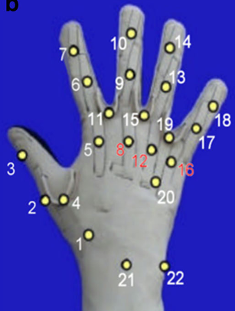

**Fig. 2** Position trackers placed in glove [6].

Participants will be asked to sit on a chair and sensors and markers will be placed on the hand and wrist: First, the motion capture cameras, IMU, and flex sensors will record the hand kinematics data. Then, the Delsys Trigno EMG sensors will be placed on their corresponding muscles, located with palpitation using medically approved hypoallergenic double-sided tapes. They will be asked to perform three tests, each composed of 20 grasp motion types. Each test has a two-minute duration which consist of performing the corresponding grasp for five seconds and resting for five more seconds. Then, there will be a three-minute resting period before starting the next test. After finishing the tests, the EMG sensors will be removed. After, a six-minute break the same test will be repeated using the MYOstack EMG sensors. Those sensors will be fitted in the same muscle locations as the Trigno sensors using an elastic band**.**

* + 1. **Glove equipped with force sensors data acquisition procedure**

The force sensor data will be obtained using a glove with the force sensitive resistors (FSR) placed on its fingertips, like *Fig. 3*.

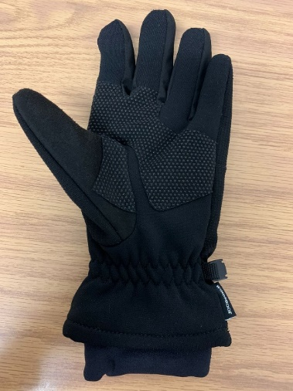

**Fig. 3** Force sensors placed in glove.

Participants will be asked to sit on a chair and wear the instrumented glove with the force sensors on its fingertips and motion tracking sensors and markers. Then, two tests will be performed: One will be performed at the same time of the EMG test (section above), to obtain the force data while doing different grasps. The second test will be performed simultaneously with the vibration actuators to assess the sensory feedback efficiency.

The sensory feedback will be delivered by several vibration actuators attached to an armband, like *Fig. 4*. Different levels of intensity will be introduced for amplitude (0.1-0.5mm neutral to peak) and frequency (60-120Hz).

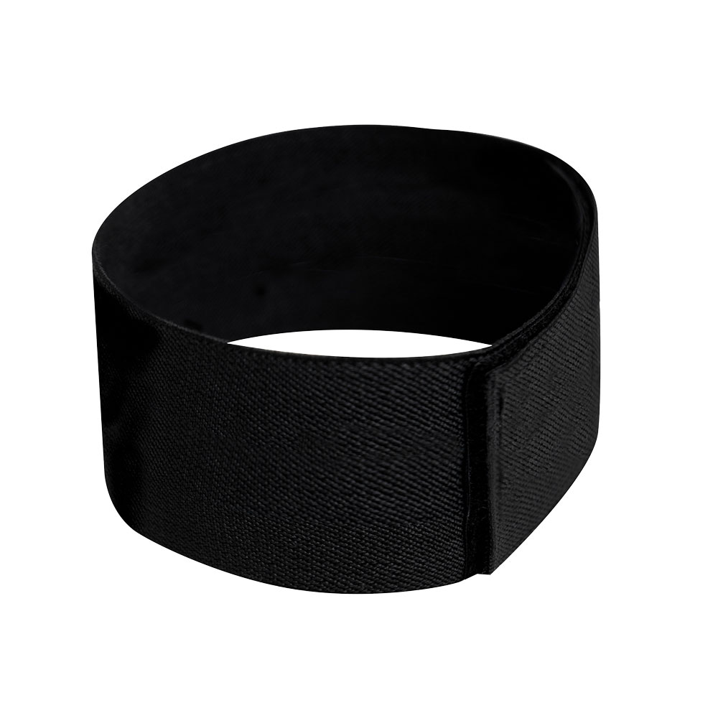

**Fig. 4** Vibration motors placed in armband.

* + 1. **Vibrators usage protocol**

Participants will wear an armband with several vibration motors attached to it, as well as the instrumented glove with force sensors and motion tracking markers and sensors. The test that has two main parts. The first part intends to find the best configuration of the vibration motors per finger, its amplitude and frequency range while doing grasps, with the hand not using the glove and armband, at different intensities perceived by the force sensor. The second part will require 10-minute training using the glove and armband with the best configuration. After that, the volunteers will be asked to remain still while using just the armband and an eye mask to have the eyes covered. Then, the investigator will grasp some objects with different intensities measured by the force sensor, and the participants will be asked what intensity they perceive and in which of their fingers. After finishing the last test, the armband and eye mask will be withdrawn from the participants.

* + 1. **Signal processing and segmentation**

EMG signal pre-processing will be carried out offline using scripts developed by our team. First, the program will be used to filter the raw EMG signal. Then, for every test, segments of each grasp repetition will be extracted. Some segments of the resting hand will also be extracted as an additional class of the three grasps. After that for every class, features will be calculated in every segment, some of the proposed features are [7]: 1) mean absolute value; 2) zero crossing; 3) slope sign changes; 4) waveform length; 4) log detector; 5) root mean square of EMG amplitude; 6) willison amplitude; and 7) maximum absolute value.

After obtaining the features, machine learning and deep learning algorithms will be used to get the classification model. Some of the proposed algorithms are: 1) logistic regression; 2) support vector machine (SVM); 3) linear discriminant analysis (LDA); 4) K-means clustering; 5) multilayer perceptron (MLP); 5) convolutional neural networks (CNN); and 6) long short-term memory (LSTM) networks.

**References**

[1] Organización Mundial de la Salud, “Normas de Ortoprostésica Parte 1: Normas,” 2017.

[2] Grand View Research, “Prosthetics & Orthotics Market Size | Industry Report, 2020-2027,” 2020. https://www.grandviewresearch.com/industry-analysis/prosthetics-orthotics-market (accessed Feb. 01, 2021).

[3] K. Østlie, I. M. Lesjø, R. J. Franklin, B. Garfelt, O. H. Skjeldal, and P. Magnus, “Prosthesis rejection in acquired major upper-limb amputees: A population-based survey,” *Disability and Rehabilitation: Assistive Technology*, vol. 7, no. 4, pp. 294–303, 2012, doi: 10.3109/17483107.2011.635405.

[4] L. E. Sánchez, M. Arias, E. Guzmán, and E. Lugo, “A Low-Cost EMG-Controlled Anthropomorphic Robotic Hand for Power and Precision Grasp,” pp. 1–17, 2019, doi: 10.1016/j.bbe.2019.10.002.

[5] A. Calado, F. Soares, and D. Matos, “A Review on Commercially Available Anthropomorphic Myoelectric Prosthetic Hands, Pattern-Recognition-Based Microcontrollers and sEMG Sensors used for Prosthetic Control,” *19th IEEE International Conference on Autonomous Robot Systems and Competitions, ICARSC 2019*, 2019, doi: 10.1109/ICARSC.2019.8733629.

[6] N. J. Jarque-Bou, A. Scano, M. Atzori, and H. Müller, “Kinematic synergies of hand grasps: A comprehensive study on a large publicly available dataset,” *Journal of NeuroEngineering and Rehabilitation*, vol. 16, no. 1, May 2019, doi: 10.1186/s12984-019-0536-6.

[7] K. Z. Zhuang *et al.*, “Shared human-robot proportional control of a dexterous myoelectric.”